Y U M E ☆ S H O U
I N T R O D U C T I O N
“The moon is beautiful tonight, isn’t it?”
Rest, sleep, the soul will be relieved, the mind travel to a land no one conceived.
In a place where anything is not what it seems, there are those girls that can only be in your DREAM.
We are made of the essence of everyone’s dream for an idol.
We will strive to be everyone’s favorite.
We bring dreamlike experience, fantastic interaction, and awe-inspiring performance.
Get ready for a show of a lifetime, we are Y U M E ☆ S H O U!!!

D R E A M
We dream to perform with all our hearts and resonate with everyone. To grow our loving supporters and cultivate healthy relationship with the supporters. Where everyone can get along and unite as one.
“We are called Y U M E ☆ S H O U”.

SOCIAL MEDIA ACCOUNTS
EXODiA Productions
www.exodiapro.com
FACEBOOK
www.facebook.com/YumeShouOfficial
INSTAGRAM
www.instagram.com/yumeshou.official
TWITTER
twitter.com/YumeshouOFC
THREADS
www.threads.net/@yumeshou.official

Members Profile


Color: Red
Nickname: Rhed
Birthday: January 3
Zodiac Sign: Capricorn
Favorite Color: Red
Favorite Animal: Rabbit
Birth place: Manila
Hobbies: Dance, Cosplay

Height: 5'0"


Facebook: rhed.yumeshou
Instagram: @rhed.yumeshou
Threads: @rhed.yumeshou
TikTok: @rhed.yumeshou
Twitter: @rhed_yumeshou


Color: Purple
Nickname: Rai
Birthday: July 23
Zodiac Sign: Leo
Favorite Color: Pink, Yellow
Favorite Animal: Panda
Birth place: Makati
Hobbies: Games, Dancing, Cosplay
Height: 5'1


Facebook: rai.yumeshou
Instagram: @rai.yumeshou
Threads: @rai.yumeshou
TikTok: @rai.yumeshou
Twitter: @rai_yumeshou
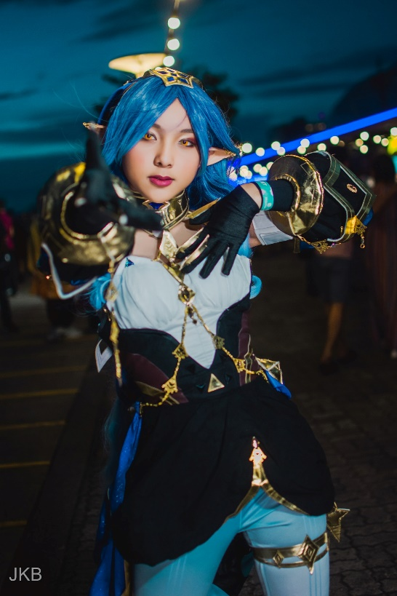


Color: Green
Nickname: Star
Birthday: August 28
Zodiac Sign: Virgo
Favorite Color: Black, Red, White
Favorite Animal: Cat
Birth place: Butuan City
Hobbies: Anime, Manga,
Drawing, Online games
Height: 5’
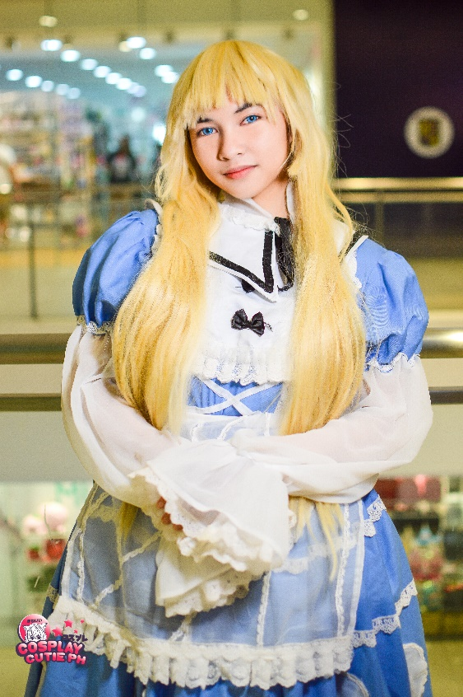
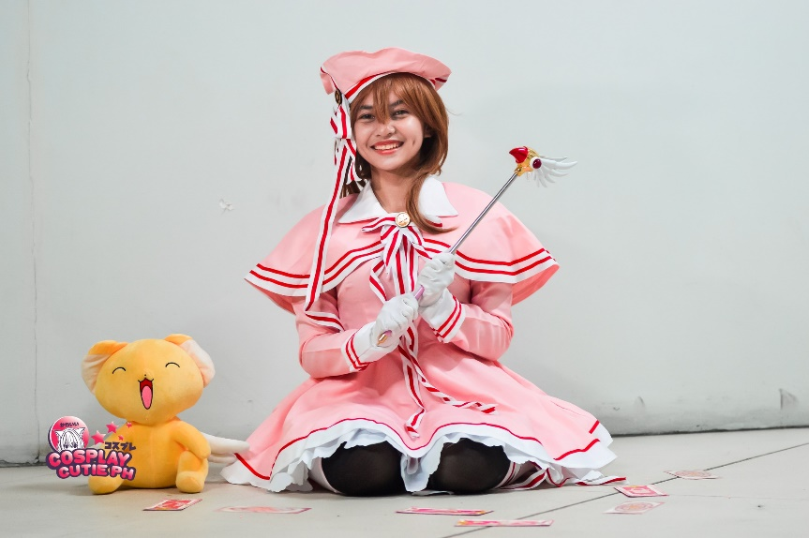
Facebook: star.yumeshou
Instagram: @star.yumeshou
Threads: @star.yumeshou
TikTok: @star.yumeshou
Twitter: @star_yumeshou


Color: Yellow
Nickname: Jea
Birthday: June 2
Zodiac Sign: Gemini
Favorite Color: Black, White, Yellow
Favorite Animal: Dog
Birth place: Pampanga
Hobbies: Playing mobile games
Height: 5’1”


Facebook: jea.yumeshou
Instagram: @jea.yumeshou
Threads: @jea.yumeshou
TikTok: @jea.yumeshou
Twitter: @jea_yumeshou



Color: Blue
Nickname: Yomi
Birthday: November 13
Zodiac Sign: Scorpio
Favorite Color: Pink
Favorite Animal: Dog
Birth place: Makati
Hobbies: Cosplay, Online games,
Drawing, Singing
Height: 4’11”

Facebook: yomi.yumeshou
Instagram: yomi.yumeshou
Threads: @yomi.yumeshou
TikTok: @yomi.yumeshou
Twitter: @yomi_yumeshou


